COMPUTER NETWORKS LAB

TOPIC:
CONFIGURE A ROUTER FOR MULTIPLE DHCP SERVERS

NAME:
MUHAMMAD TALHA
SECTION:
4/A
ROLL#:
241890

INSTRUCTOR:
MR. MUHAMMAD BILAL

LAB TASK#1
How to configure a router for multiple DHCP servers
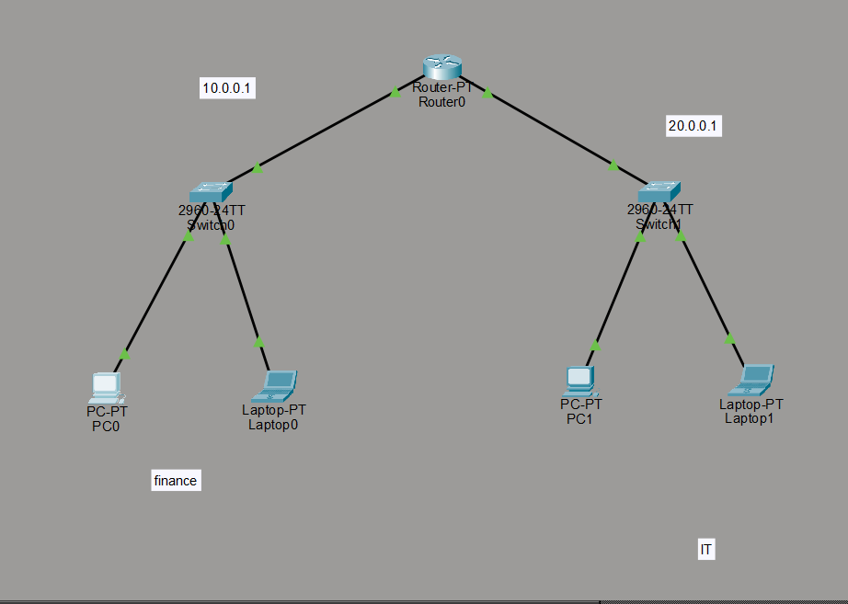
PC CONFIGUARTIONS:
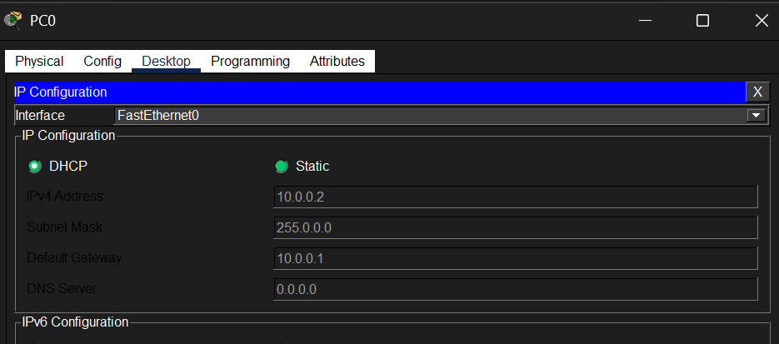

ROUTER CONFIGURATION:
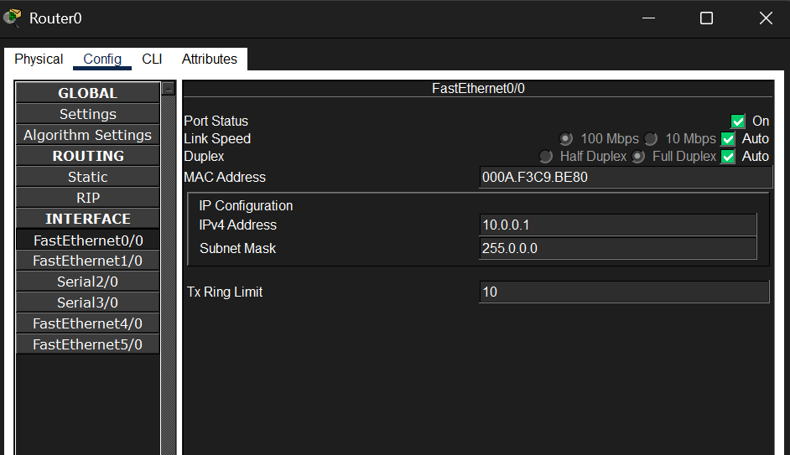
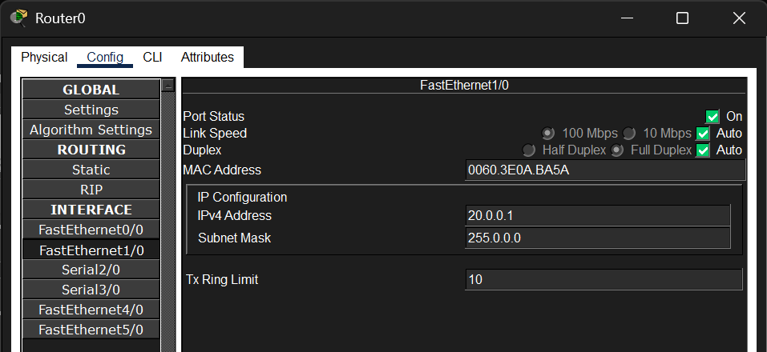

RESULTS:
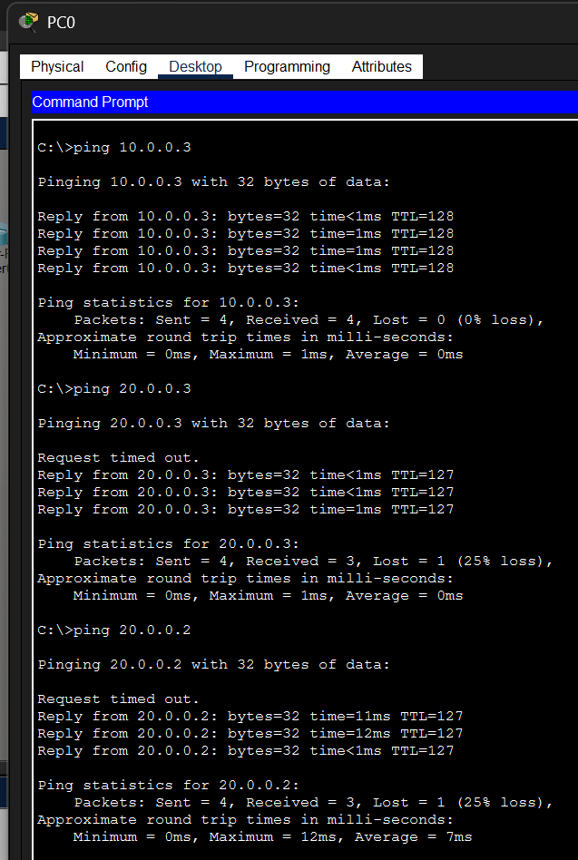

LAB TASK #2
Configuring DHCP service on a generic server in Packet Tracer.
TOPOLOGY:
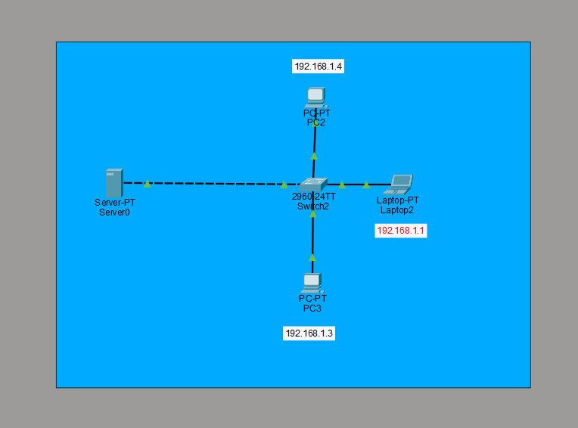
SERVER CONFIGURATION:
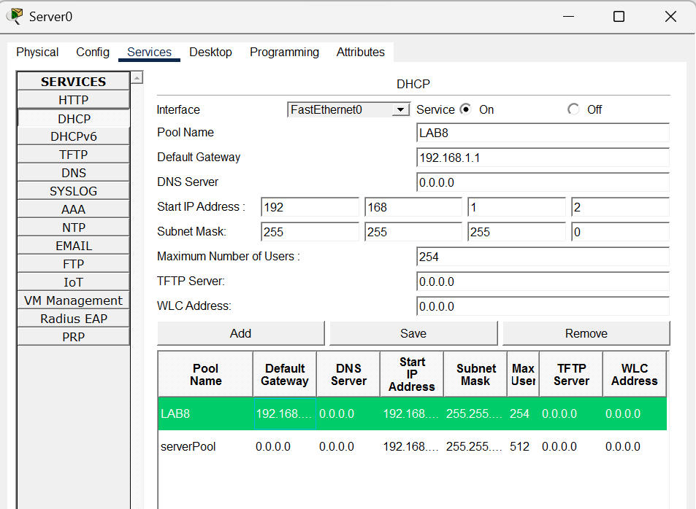
PC CONFIGUARTION:
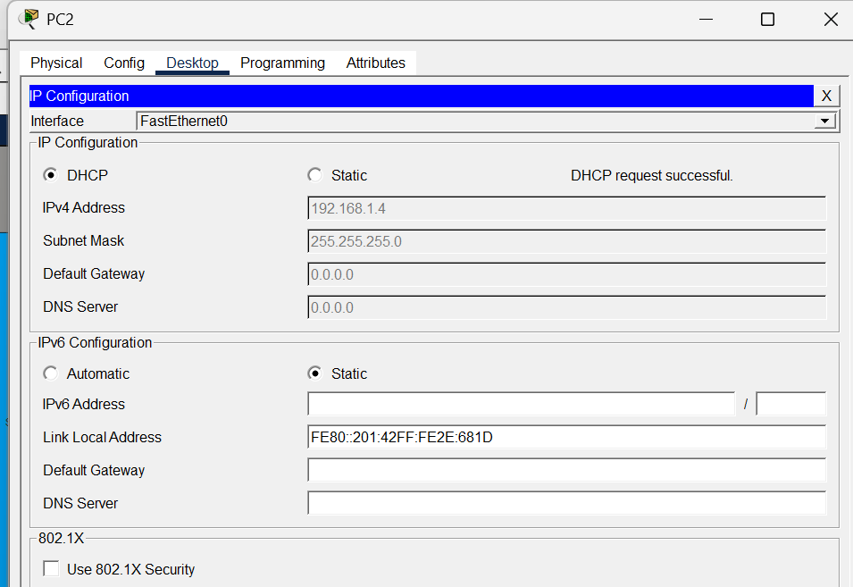
RESULTS:
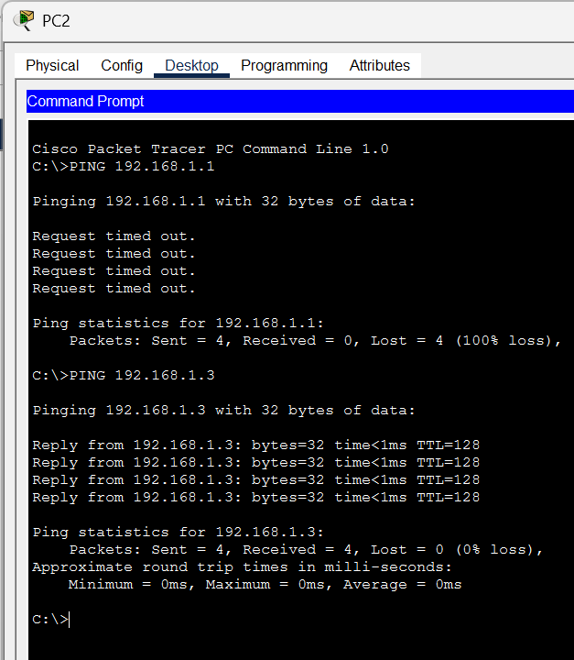
LAB TASK #3
Configure single Router as four DHCP SERVER in cisco packet tracer
TOPOLOGY:
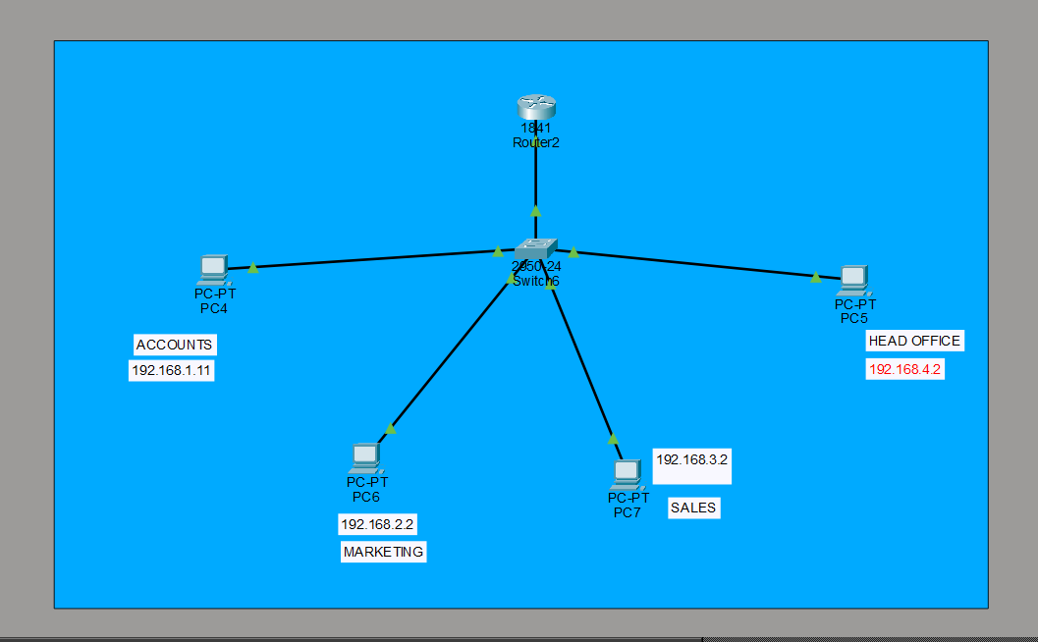
ROUTER CONFIGURATION:
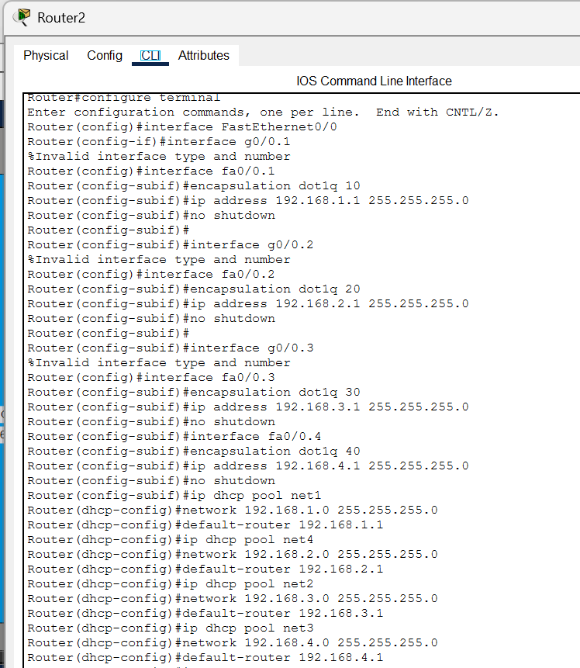
PC CONFIGURATIONS:
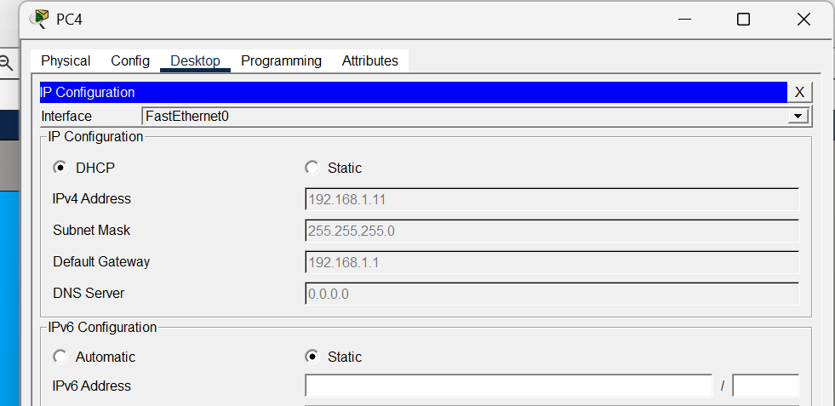
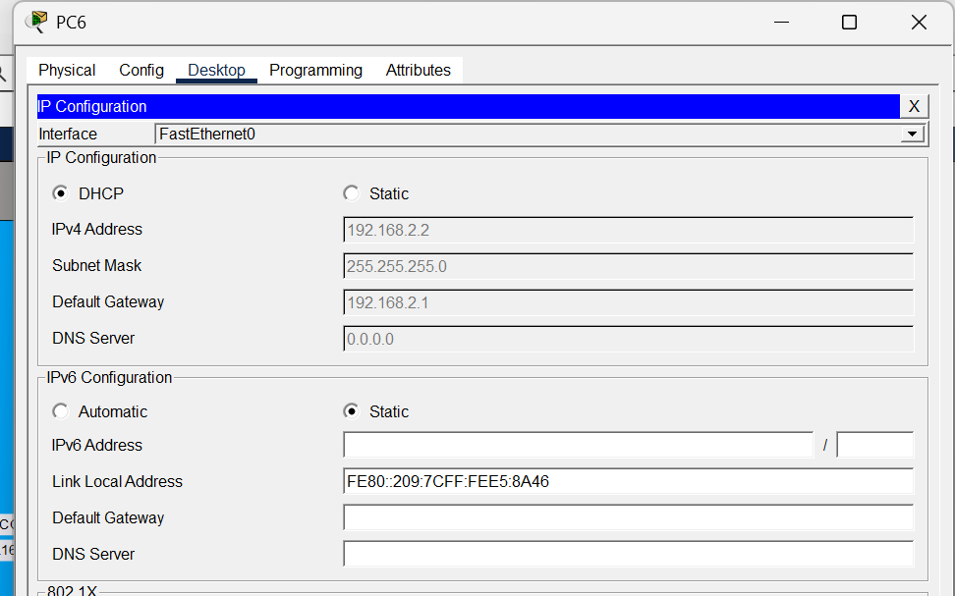
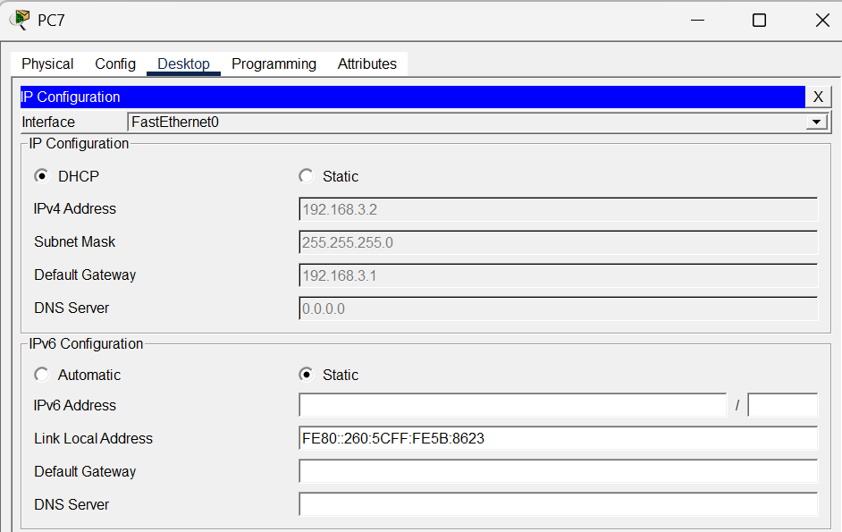
RESULTS:
